JAMHURIYA UNIVERSITY OF SCIENCE AND TECHNOLOGY
Faculty of Computer and Information Technology
LINUX COMMANDS
A Detailed Practical Study of Chapters 1–4
Principles of Linux Operating Systems

Prepared by: ___Neima Hassan Dirie________
Student ID: _____C6240147_________________
Department: Networking and Cybersecurity
Lecturer: _______Ustaad Nasri_____________
Submission date: _______11/11/2026________
Academic Year 2026

Abstract
This project presents a practical and structured explanation of the Linux commands, shell operations, file-management techniques, text-processing utilities, archive tools, process controls, service-management commands, and system-inspection methods covered in Chapters 1–4 of Principles of Linux Operating Systems. Each command entry explains its purpose, general syntax, a safe sequence of use, a Bash example, and the meaning of the expected result. The project follows the terminology and learning sequence of the supplied lecture materials. Terminal outputs are illustrative: actual usernames, process identifiers, file paths, package availability, and system values differ between computers.

Project objectives
- Explain the commands and command-line techniques introduced in the four supplied chapters.
- Show how to use commands through clear, repeatable terminal procedures.
- Interpret command output instead of memorising command names alone.
- Practise file navigation, file operations, searching, text processing, archiving, and process management.
- Recognise safety considerations, permissions, and the difference between read-only inspection and commands that change the system.

How to use this project
The examples assume an Ubuntu terminal using Bash. The prompt symbol $ represents a normal user. Do not type the $ symbol itself. Replace sample filenames, usernames, process IDs, and directories with values from your own machine. Commands that use sudo require administrator privileges. For destructive operations, first practise in a temporary directory and inspect the target before pressing Enter.

Important note about evidence
The supplied slides contain illustrative terminal examples rather than screenshots captured from the student's own virtual machine. This project therefore provides Bash commands and representative output for every command entry. If the lecturer specifically requires personal screenshots, run the examples in the Ubuntu VM and insert your own screenshots beside the matching sections.

Contents
- Chapter 1: Introduction to Linux and Ubuntu
- Chapter 2: System Architecture, Bash, and File Management
- Chapter 3: Text Processing, Searching, Archiving, and Editors
- Chapter 4: Process, Service, and System Management
- Practical integrated lab
- Conclusion
- References

Chapter 1: Introduction to Linux and Ubuntu
Chapter 1 introduces the operating system, Linux kernel, distributions, Ubuntu, and the virtual-machine lab. Its terminal examples are introductory inspection commands. Most of the chapter is conceptual rather than a command catalogue.

1.1 | whoami
Displays the username of the account currently running the shell. It is useful for checking which account will own files created in the terminal and whether the session is using the expected user.
General syntax: whoami.
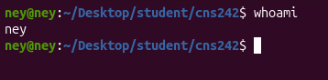
What the result means: The output student is an illustrative account name. Your machine prints your actual login name.
Safety and practical notes: This command does not change account settings or require administrator privileges.

1.2 | pwd
Prints the present working directory, meaning the directory in which relative paths are interpreted.
General syntax: pwd.
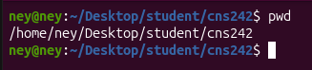
What the result means: The example shows that the shell is currently in the student's home directory.
Safety and practical notes: Use pwd before moving, deleting, or creating files if you are unsure which directory is active.

1.3 | uname
Purpose:Print facts about the running kernel and the machine type.Syntax. uname [-r] [-s] [-m] [-n] [-a]
Prints basic system information. Without options it commonly displays the kernel name; options select more specific details.

Option | Prints
`-s` | Kernel/OS name (`Linux`, or `Darwin` on macOS)
`-r` | Kernel release
`-m` | Machine hardware architecture
`-n` | Hostname (node name)
`-a` | All fields on one line

General syntax: uname
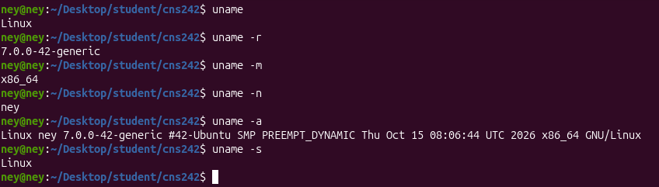
What the result means: The exact version varies according to the installed Ubuntu release and updates.
Safety and practical notes: The -r option selects the kernel release. It is an inspection command.

1.4 | cat /etc/os-release
Prints operating-system identification information stored in /etc/os-release. It helps identify the installed distribution and version.
General syntax: cat /etc/os-release
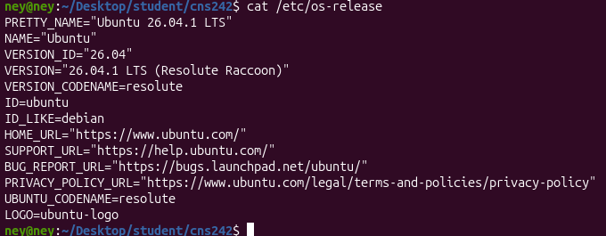
What the result means: The values identify the Linux distribution. Your release may be newer or older.
Safety and practical notes: cat displays file contents. This use is read-only; do not edit the file merely to identify the OS.

1.5 | ls (first use)
Purpose: List the contents of a directory.
General syntax: uname [options]
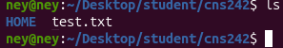
Output explained. With no argument, ls lists the current directory. With / it lists the root of the single Linux tree — there are no drive letters.

Chapter 2: Linux System Architecture, Command Line, and File Management
Chapter 2 moves from the system map to Bash and then to everyday filesystem operations. A command line normally contains a command name, optional options, and arguments. For example, in ls -lh /home, ls is the command, -lh contains options, and /home is the argument.

2.1 Filesystem locations and shell concepts
/ The root of the filesystem tree. Every mounted directory is reached from this starting point.
/home Contains users' personal home directories and ordinary personal files.
/etc Contains system-wide configuration files.
/var Contains variable data such as logs, caches, and service data.
/usr Contains many user-space programs, libraries, documentation, and shared resources.
/tmp Provides temporary space. Files may be removed automatically.
/boot Contains files needed during the boot process, including kernel and bootloader-related files.
/dev Contains device nodes through which programs access devices.
/proc A virtual, kernel-provided view of processes and system information.
/sys A virtual filesystem exposing kernel device and subsystem information.
These paths are filesystem locations, not commands. They are included because the lecture objectives require students to identify what each directory contains.

2.1 | man
Opens the manual page for a command or topic.
Manual sections. 1 = user commands, 5 = file formats, 8 = administration commands.

pager keys. Space next page. b back a page · /word search · n next match · h help · q quit.
General syntax: man [section] command
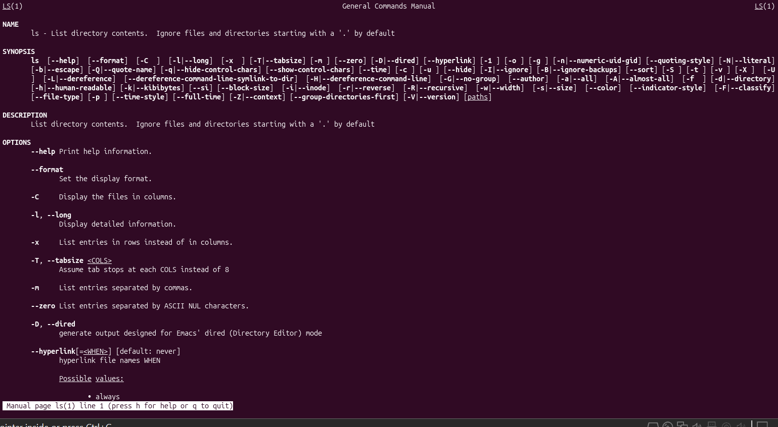
What the result means: The manual explains purpose, syntax, options, and related information.
Safety and practical notes: man is a help command. man 1 passwd refers to the user command; man 5 passwd refers to the file format manual section.

2.2 | --help
Many commands provide a short usage summary through the --help option.
General syntax: command –help
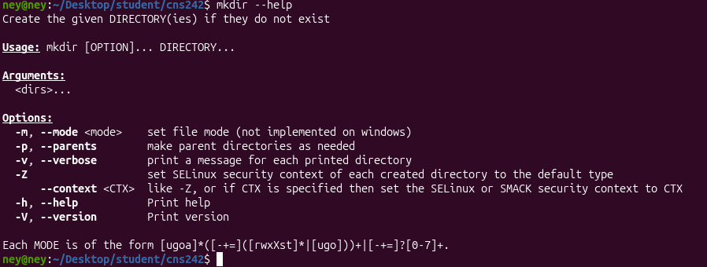
What the result means: The output is a compact list of options and their meanings.
Safety and practical notes: Not every program implements --help in exactly the same way. Use man when more detail is needed.

2.3 | info
Opens GNU Info documentation when available for a command or software package.
General syntax: info [topic]
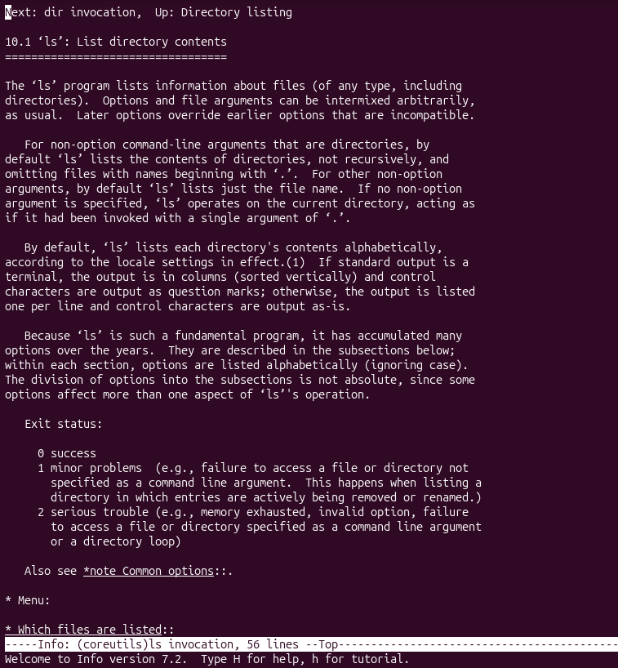
What the result means: The Info reader presents structured documentation with linked sections.
Safety and practical notes: Some systems do not have an Info page for every command.

2.4 | history
Displays previously entered shell commands from the current Bash history list.
General syntax: history [number]
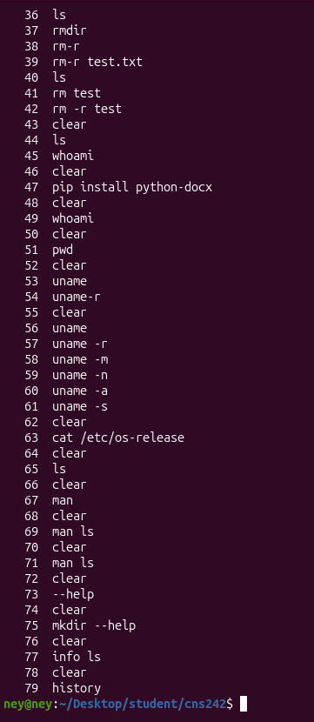
What the result means: The numbers identify entries in the shell history list.
Safety and practical notes: History may contain sensitive commands. Do not share terminal history without checking it first.

2.5 | type
Identifies how Bash resolves a command name, such as a built-in, alias, function, or executable.
General syntax: type command
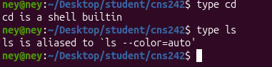
What the result means: cd is implemented by Bash because it must change the shell's own working directory. ls is an executable file.
Safety and practical notes: This command is useful when a command behaves differently from what you expect.

2.6 | command -v
Reports how the shell would resolve a command name.
General syntax: command -v name
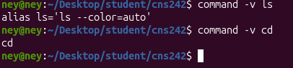
What the result means: An executable may be shown by its path; a built-in may be identified by its name.
Safety and practical notes: The path may differ across Linux distributions.

2.7 | which
Searches PATH for an executable file with the requested name.
General syntax: which command
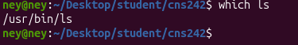
What the result means: The output is the location of the executable found through PATH.
Safety and practical notes: which may not identify shell built-ins such as cd. Use type or command -v for shell resolution.

2.8 | whereis
Locates binary files, source files, and manual pages associated with a command.
General syntax: whereis command
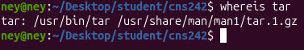
What the result means: The locations are examples and may vary.
Safety and practical notes: whereis searches standard locations; it is not a general-purpose content search.

2.9 | echo
Displays text or the value of shell variables.
General syntax: echo [text or variable]
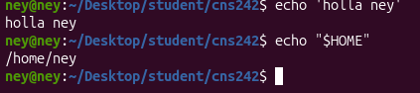
What the result means: The first line prints text. The second displays the home-directory variable's value.
Safety and practical notes: Quotes help preserve spaces and prevent unwanted shell expansion.

2.10 | printf
Prints formatted text. It is useful when predictable spacing and newline behavior are required.
General syntax: printf 'format' [arguments]
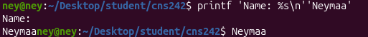
What the result means: The %s placeholder is replaced by the supplied text, and \n creates a new line.
Safety and practical notes: printf is a Bash built-in in common Bash installations and also exists as an external utility.

2.11 | export
Marks a shell variable for inclusion in the environment of subsequently started child processes.
General syntax: export NAME=value
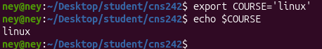
What the result means: The shell prints the value assigned to COURSE.
Safety and practical notes: Environment variables are conventionally written in uppercase, although this is a naming convention rather than a requirement.

2.12 | printenv
Displays environment variables, or the value of a named variable.
General syntax: printenv [VARIABLE]
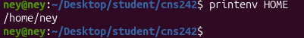
What the result means: The output is the value stored in the environment variable.
Safety and practical notes: Avoid publishing environment output if it contains tokens or other secrets.

2.13 | PATH
PATH is an environment variable containing directories Bash searches for executable commands. It is a variable, not a command.
General syntax: echo "$PATH"
What the result means: Each colon-separated entry is a directory searched for executable names.
Safety and practical notes: Do not overwrite PATH with a single directory. If changing it, preserve existing entries.

2.14 | ~/.bashrc
A Bash configuration file read for interactive non-login shells. It commonly stores aliases, prompt settings, and user-specific shell configuration.
General syntax: cat ~/.bashrc
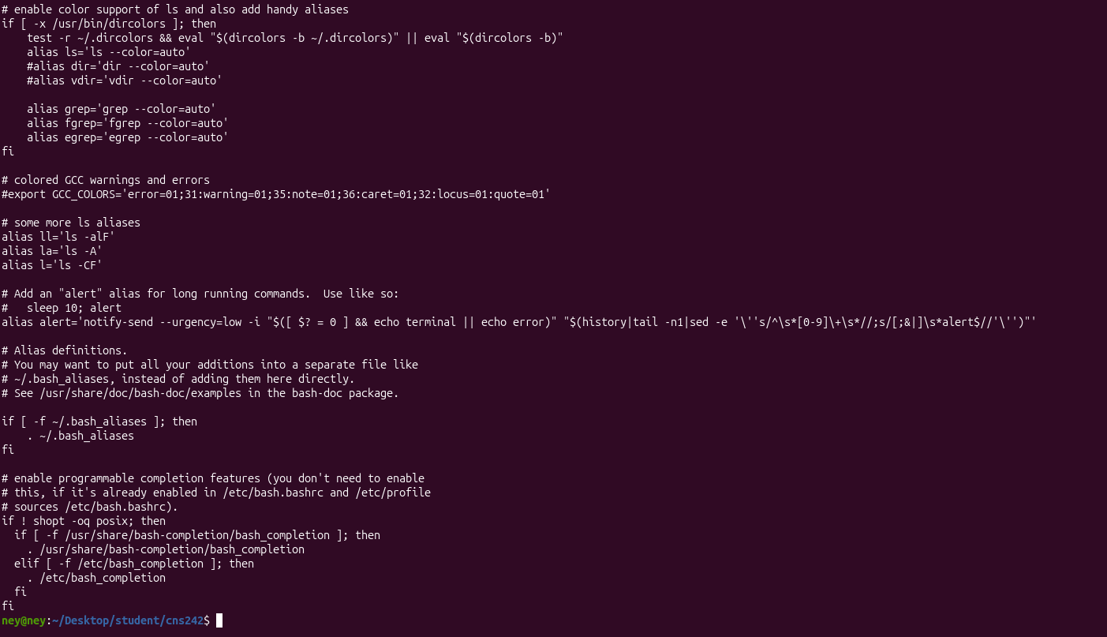
What the result means: The file contains user-specific Bash settings.
Safety and practical notes: A syntax mistake in this file can affect future terminal sessions. Make a backup before editing.

2.15 | pwd
Prints the current working directory.
General syntax: pwd
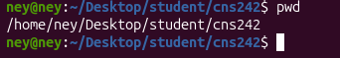
What the result means: The shell is in /home/student in this example.
Safety and practical notes: An absolute path starts from /; a relative path starts from the current directory.

2.16 | cd
Changes the shell's current working directory.
General syntax: cd [directory]
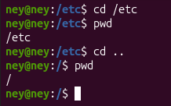
What the result means: cd changes the current location. It produces no output when successful in ordinary use.
Safety and practical notes: Because cd changes the current shell, it is normally a shell built-in.

2.17 | ls
Lists files and directories.
General syntax: ls [options] [path]
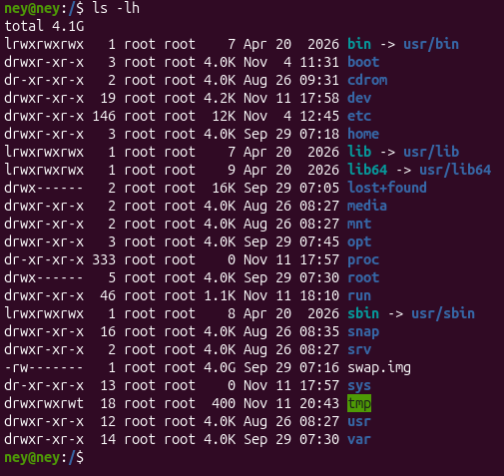
What the result means: The long listing includes permissions, link count, owner, group, size, date, and name.
Safety and practical notes: Use ls -la when hidden files and detailed metadata are both needed.

2.18 | mkdir
Creates directories.
General syntax: mkdir [options] directory
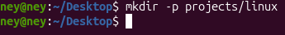
What the result means: The nested directory projects/linux is created.
Safety and practical notes: Check the target path before using options that affect existing directories.

2.19 | touch
Creates an empty file if it does not exist, or updates timestamps on an existing file.
General syntax: touch filename
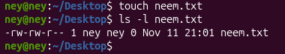
What the result means: The file exists and has zero bytes in this example.
Safety and practical notes: touch does not normally add text to the file. It also changes timestamps when the file already exists.

2.20 | cp
Copies files or directories. Directories require the recursive option.
General syntax: cp [options] source destination
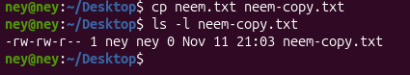
What the result means: A second file is created with copied content.
Safety and practical notes: Be careful when the destination already exists because cp can overwrite it. Use -i for an interactive confirmation.

2.21 | mv
Moves a file or directory, and is also used to rename items.
General syntax: mv [options] source destination
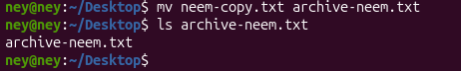
What the result means: The original pathname is replaced by the new pathname.
Safety and practical notes: mv can overwrite an existing destination. Use -i to request confirmation.

2.22 | rm
Removes file directory entries. Removal may be difficult or impossible to reverse.
General syntax: rm [options] file

What the result means: The file is removed after confirmation.
Safety and practical notes: Never experiment with rm -rf on important paths. Do not run destructive commands copied from unknown sources.

2.23 | rmdir
Removes an empty directory.
General syntax: rmdir directory
What the result means: The empty directory is removed.
Safety and practical notes: rmdir refuses to remove a non-empty directory, which makes it safer than recursive deletion for empty folders.

2.24 | Tab completion
Bash can complete command names and file paths when the Tab key is pressed. It is a shell feature, not a standalone command.
General syntax: type part-of-name then press Tab
What the result means: The terminal completes a matching path where possible.
Safety and practical notes: Completion reduces typing errors. Case and spaces in names still matter.

2.25 | Quoting and escaping
Single quotes preserve literal characters; double quotes allow variable expansion; a backslash can escape a special character.
General syntax: 'text' | "text $VAR" | \character
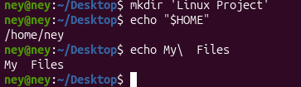
What the result means: The first command creates one directory containing a space. The second expands HOME. The third prints a word containing an escaped space.
Safety and practical notes: Quoting is essential when filenames contain spaces or shell metacharacters.

2.26 | Wildcards
Bash filename patterns include * for any sequence, ? for one character, and bracket expressions such as [abc].
General syntax: command pattern
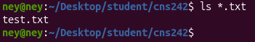
What the result means: The shell expands the pattern into matching filenames before running ls.
Safety and practical notes: Quote a pattern when you want a program such as find to receive the wildcard literally.

Chapter 3: Text Processing, Searching, Archiving, and Editors
Chapter 3 focuses on inspecting file contents and metadata, finding files and text, combining commands, archiving data, compression, and links. Many examples use small sample files. Create them in a temporary practice directory so that commands do not affect important data.

3.1 | cat
Displays file contents and can concatenate multiple files.
General syntax: cat [options] [file...]

What the result means: The three lines are printed to standard output.
Safety and practical notes: cat is useful for short files. For long files, less is easier to navigate.

3.2 | less
Displays text one screen at a time and allows forward/backward navigation.
General syntax: less filename

Step-by-step use
- Run less app.log.
- Press Space to move forward and b to move backward.
- Type /ERROR to search and n for the next match.
- Press q to quit.

Bash example
less app.log
[the file opens in a scrollable pager]
What the result means: Only a portion of the file is shown at once.
Safety and practical notes: less does not edit the file. It is suitable for large logs and text files.

3.3 | head
Displays the first lines of a file. The default is ten lines.
General syntax: head [options] file
What the result means: The first two lines are displayed.
Safety and practical notes: The -n option controls the number of lines.

3.4 | tail
Displays the last lines of a file. It can also follow new lines as they are added.
General syntax: tail [options] file

Step-by-step use
- Run tail filename to see the final ten lines.
- Use -n 2 for the last two lines.
- Use -f to monitor appended lines.
- Press Ctrl+C to stop following.

Bash example
tail -n 2 app.log
WARN retry
ERROR login failed
tail -f app.log
[waits for appended lines; Ctrl+C stops]
What the result means: The first command prints the final two lines. The -f form continues monitoring.
Safety and practical notes: Use tail -f for logs. Ctrl+C stops the foreground monitoring process.

3.5 | file
Identifies a file's type by examining its contents rather than trusting its extension.
General syntax: file filename

Step-by-step use
- Choose a file.
- Run file filename.
- Read the detected type.

Bash example
file notes.txt
notes.txt: ASCII text
What the result means: The result identifies the content type detected by the utility.
Safety and practical notes: A filename extension can be misleading; file examines file data.

3.6 | stat
Displays detailed filesystem metadata for a file or directory.
General syntax: stat filename

Step-by-step use
- Run stat notes.txt.
- Inspect size, inode, permissions, owner, and timestamps.
- Compare with the shorter ls -l listing.

Bash example
stat notes.txt
File: notes.txt
Size: 16 Blocks: 8 IO Block: 4096 regular file
Access: (0644/-rw-r--r--) Uid: (...)
What the result means: The output provides detailed metadata; values depend on the actual file.
Safety and practical notes: stat is an inspection command and does not change file contents.

3.7 | find
Searches directory trees using conditions such as name, type, size, and modification time.
General syntax: find starting-path tests

Step-by-step use
- Start with find . to search from the current directory.
- Use -name 'names.txt' to match a filename.
- Use -type f for regular files or -type d for directories.
- Combine tests to narrow the results.

Bash example
find . -name 'names.txt'
./names.txt
find project -type d
project
project/src
What the result means: The matching paths are printed. The dot means the current directory.
Safety and practical notes: Quote wildcard patterns so the shell does not expand them before find receives them.

3.8 | find by size and time
The find command can select files based on size or recent modification.
General syntax: find path -type f -size +10c
find path -type f -mmin -30

Step-by-step use
- Use -size +10c to find files larger than ten bytes.
- Use -size -10M to find files smaller than ten MiB.
- Use -mmin -30 to find files modified within the last thirty minutes.

Bash example
find . -name 'names.txt' -size +10c
./names.txt
find . -type f -mmin -30
[recently modified files]
What the result means: The first result meets both the name and size tests. The second lists recently modified regular files.
Safety and practical notes: Size suffixes include c for bytes, k for KiB, M for MiB, and G for GiB. A plus means greater than; a minus means less than.

3.9 | locate
Searches a prebuilt database of file paths, often faster than scanning directories at run time.
General syntax: locate pattern

Step-by-step use
- Run locate names.txt.
- Review any matching indexed paths.
- If a recently created file is missing, remember that the database may be stale.

Bash example
locate names.txt
/home/student/project/names.txt
What the result means: The output lists paths known to the index.
Safety and practical notes: locate may be implemented by plocate and may need installation. Its results depend on the database being refreshed.

3.10 | updatedb
Refreshes the database used by locate on systems that provide this utility.
General syntax: sudo updatedb

Step-by-step use
- Open a terminal with administrator access available.
- Run sudo updatedb if the command exists.
- Wait for indexing to finish, then retry locate.

Bash example
sudo updatedb
[sudo may request the user's password]
What the result means: The database is updated; many implementations produce no success message.
Safety and practical notes: The command may require administrator privileges and may not be installed by default.

3.11 | grep
Searches file contents for lines matching a text pattern.
General syntax: grep [options] PATTERN FILE

Step-by-step use
- Choose a text file or log.
- Run grep 'Ali' names.txt.
- Use -n to show matching line numbers and -i to ignore case.

Bash example
grep -n 'ERROR' app.log
2:ERROR disk full
4:ERROR login failed
What the result means: Matching lines are printed, with line numbers when -n is used.
Safety and practical notes: grep searches content, while find and locate search filesystem paths.

3.12 | sort
Sorts lines of text.
General syntax: sort [options] file

Step-by-step use
- Run sort names.txt.
- Use -r for reverse order.
- Use -n for numeric sorting when lines contain numbers.

Bash example
sort names.txt
Ali
Hodan
Yusuf
What the result means: The lines are displayed in sorted order.
Safety and practical notes: sort normally writes results to standard output; redirect output if you want to save it.

3.13 | uniq
Reports or filters adjacent repeated lines. It is commonly used after sort.
General syntax: uniq [options] [input]

Step-by-step use
- Sort the input first if duplicates may be separated.
- Run sort names.txt | uniq.
- Use -c to count repeated adjacent lines.

Bash example
printf 'bash\nsh\nbash\n' | sort | uniq -c
2 bash
1 sh
What the result means: The count indicates how many times each adjacent group occurs.
Safety and practical notes: uniq alone does not find duplicates that are separated by other lines.

3.14 | cut
Extracts selected fields or character positions from each input line.
General syntax: cut -d delimiter -f fields file

Step-by-step use
- Choose a delimiter such as a colon.
- Use -d: to set the delimiter.
- Use -f3 to select the third field.

Bash example
cut -d: -f3 users.txt
bash
bash
sh
What the result means: The third colon-separated field is printed in this example.
Safety and practical notes: cut is useful for simple delimiter-separated records. It is not a full CSV parser.

3.15 | paste
Merges corresponding lines from files side by side, using a tab by default.
General syntax: paste [options] file1 file2

Step-by-step use
- Prepare two files with corresponding lines.
- Run paste file1 file2.
- Use -d to choose a different delimiter if needed.

Bash example
paste first.txt last.txt
Ali Hassan
Hodan Yusuf
What the result means: Lines from the two files are joined on the same output line.
Safety and practical notes: The files should have compatible line counts for predictable results.

3.16 | wc
Counts lines, words, bytes, or characters.
General syntax: wc [options] [file]

Step-by-step use
- Run wc filename for several counts.
- Use -l for lines, -w for words, and -c for bytes.
- Use input redirection when a filename should not appear in output.

Bash example
wc -l names.txt
3 names.txt
wc -l < names.txt
3
What the result means: The first output includes the filename; redirected input produces only the count.
Safety and practical notes: The exact count depends on the file content.

3.17 | tr
Translates or deletes characters from standard input. It reads from stdin and writes transformed text to stdout.
General syntax: tr [options] SET1 [SET2]

Step-by-step use
- Redirect a file into tr using <.
- Use 'a-z' and 'A-Z' to convert lowercase letters to uppercase.
- Pipe or redirect the result if you need to save it.

Bash example
tr 'a-z' 'A-Z' < names.txt
ALI
HODAN
YUSUF
What the result means: The lowercase letters are converted to uppercase.
Safety and practical notes: The < operator changes where the command reads input; it does not edit the original file.

3.18 | Redirection operators
Shell redirection changes where commands read input or send output. These are shell operators, not standalone commands.
General syntax: command > file
command >> file
command < file

Step-by-step use
- Use > to write output to a file, replacing its previous contents.
- Use >> to append output to the end of a file.
- Use < to read input from a file.

Bash example
echo 'First line' > report.txt
echo 'Second line' >> report.txt
cat < report.txt
First line
Second line
What the result means: The first command creates or replaces the file; the second appends; the third reads it as standard input.
Safety and practical notes: Be careful with > because it overwrites an existing file.

3.19 | Pipe operator |
Connects standard output from one command to standard input of the next command.
General syntax: command1 | command2

Step-by-step use
- Choose a command that prints text.
- Place | after it.
- Write a second command that can read standard input.
- Add more stages if required.

Bash example
grep -i 'ERROR' app.log | sort | uniq -c
2 ERROR ...
What the result means: The right-hand command processes the output of the left-hand command.
Safety and practical notes: A normal pipe transfers stdout, not stderr. A pipeline can be chained without creating temporary files.

3.20 | Command chaining ; && ||
Controls whether multiple commands run unconditionally or depending on success or failure.
General syntax: cmd1 ; cmd2
cmd1 && cmd2
cmd1 || cmd2

Step-by-step use
- Use ; when both commands should run regardless of the first result.
- Use && when the second command should run only if the first succeeds.
- Use || when the second command should run only if the first fails.

Bash example
printf 'one\n'; printf 'two\n'
one
two
test -f missing.txt || echo 'Not found'
Not found
What the result means: The semicolon runs both commands. The OR operator runs the fallback message because the test fails.
Safety and practical notes: A successful command usually returns exit status 0. A non-zero status generally indicates failure.

3.21 | $? exit status
The special Bash variable $? contains the exit status of the most recently completed command.
General syntax: echo $?

Step-by-step use
- Run a simple successful command.
- Immediately run echo $? .
- Repeat after a command that fails to see a non-zero status.

Bash example
true
echo $?
0
false
echo $?
1
What the result means: Zero indicates success; non-zero indicates an unsuccessful result.
Safety and practical notes: The value changes after every command, so inspect it immediately after the command of interest.

3.22 | tar
Creates, lists, and extracts archives. Archiving groups files; it does not necessarily compress them.
General syntax: tar [options] archive files

Step-by-step use
- Create an archive with -c and -f.
- Use -v to display processed names.
- List contents with -t.
- Extract with -x after checking the archive.

Bash example
tar -cvf backup.tar project/
tar -tf backup.tar
tar -xvf backup.tar
What the result means: The first command creates an archive, the second lists it, and the third extracts it.
Safety and practical notes: The -f option is followed by the archive filename. Extract into a safe directory and inspect contents first.

3.23 | tar compression options
tar can combine archiving with gzip, bzip2, or xz compression.
General syntax: tar -czf archive.tar.gz folder/
tar -cjf archive.tar.bz2 folder/
tar -cJf archive.tar.xz folder/

Step-by-step use
- Use -z for gzip compression.
- Use -j for bzip2 compression.
- Use -J for xz compression.
- Use -C directory to change directory before processing paths.

Bash example
tar -czvf project.tar.gz project/
tar -tzf project.tar.gz
What the result means: The archive is created with gzip compression, then its contents are listed.
Safety and practical notes: The option letters are case-sensitive. -J is uppercase for xz.

3.24 | gzip
Compresses files using the gzip format. By default, it replaces the input file with a .gz file.
General syntax: gzip [options] file

Step-by-step use
- Choose a file to compress.
- Run gzip filename.
- Use gzip -d filename.gz to decompress, or gunzip filename.gz.

Bash example
gzip report.txt
ls report.txt.gz
gzip -d report.txt.gz
What the result means: The compressed file is created; decompression restores the original filename.
Safety and practical notes: Keep a copy if the original must be preserved. Compression ratio depends on file contents.

3.25 | gunzip
Decompresses gzip-compressed files. It is commonly used with .gz files.
General syntax: gunzip file.gz

Step-by-step use
- Check that the file ends in .gz.
- Run gunzip file.gz.
- List the directory to verify the restored file.

Bash example
gunzip report.txt.gz
ls report.txt
What the result means: The compressed file is decompressed into report.txt.
Safety and practical notes: The input .gz file is normally removed after successful decompression.

3.26 | bzip2
Compresses files using the bzip2 format.
General syntax: bzip2 [options] file

Step-by-step use
- Run bzip2 filename to compress.
- Use bzip2 -d filename.bz2 to decompress.
- Verify the resulting file.

Bash example
bzip2 report.txt
ls report.txt.bz2
bzip2 -d report.txt.bz2
What the result means: A .bz2 file is produced and can later be decompressed.
Safety and practical notes: Compression may be slower than gzip but can produce smaller output for some data.

3.27 | xz
Compresses files using the xz format.
General syntax: xz [options] file

Step-by-step use
- Run xz filename to compress.
- Use xz -d filename.xz to decompress.
- Check the restored file.

Bash example
xz report.txt
ls report.txt.xz
xz -d report.txt.xz
What the result means: The compressed file uses the .xz extension.
Safety and practical notes: The xz format often compresses strongly but can require more processing time.

3.28 | zip
Creates a ZIP archive, optionally including multiple files and directories.
General syntax: zip [options] archive.zip files

Step-by-step use
- Choose the files or directory to package.
- Run zip archive.zip file1 file2.
- Use -r when adding a directory tree.

Bash example
zip -r project.zip project/
adding: project/ (stored 0%)
What the result means: The ZIP archive contains the selected items.
Safety and practical notes: Inspect the file list before sharing or extracting archives from untrusted sources.

3.29 | unzip
Lists or extracts the contents of ZIP archives.
General syntax: unzip [options] archive.zip

Step-by-step use
- Use unzip -l archive.zip to list contents.
- Choose a safe destination directory.
- Run unzip archive.zip or unzip -d destination archive.zip.

Bash example
unzip -l project.zip
Archive: project.zip
Length Name
... project/
What the result means: The listing shows files stored in the archive.
Safety and practical notes: Review archive paths before extraction, especially when the archive comes from an unknown source.

3.30 | ln hard link
Creates another directory entry that refers to the same inode as an existing file.
General syntax: ln existing-file hard-link-name

Step-by-step use
- Create a regular source file.
- Run ln source.txt source-hard.txt.
- Use ls -li to compare inode numbers.
- Write through one name and read through the other.

Bash example
cp notes.txt link-source.txt
ln link-source.txt link-hard.txt
ls -li link-source.txt link-hard.txt
[same inode number, link count 2]
What the result means: Both names refer to the same underlying file data.
Safety and practical notes: Hard links generally cannot cross filesystem boundaries and are not normally used for directories.

3.31 | ln -s symbolic link
Creates a symbolic link that stores a path to another file or directory.
General syntax: ln -s target link-name

Step-by-step use
- Choose an existing target.
- Run ln -s target shortcut.
- Use ls -l to inspect the arrow and target path.
- Read through the link to confirm it resolves.

Bash example
ln -s link-source.txt link-shortcut.txt
ls -l link-shortcut.txt
link-shortcut.txt -> link-source.txt
What the result means: The link points to the target pathname.
Safety and practical notes: A symbolic link can become dangling if the target is moved or deleted. Relative targets are resolved from the link's directory.

3.32 | nano
A simple terminal text editor. It opens a file for editing and displays keyboard shortcuts at the bottom.
General syntax: nano filename

Step-by-step use
- Run nano notes.txt.
- Type or edit the required text.
- Press Ctrl+O to write the file and confirm the filename.
- Press Ctrl+X to exit.

Bash example
nano notes.txt
[editor opens]
Ctrl+O Save
Ctrl+X Exit
What the result means: The file is saved when the write operation is confirmed.
Safety and practical notes: Do not close the terminal window before saving. Shortcut labels may show ^O for Ctrl+O.

3.33 | vim
A modal terminal text editor. It has normal mode for commands and insert mode for entering text.
General syntax: vim filename

Step-by-step use
- Run vim notes.txt.
- Press i to enter insert mode and type text.
- Press Esc to return to normal mode.
- Type :wq and press Enter to save and quit.

Bash example
vim notes.txt
[i] type text
[Esc]
:wq
What the result means: The file is saved and the editor closes.
Safety and practical notes: To quit without saving, return to normal mode and use :q! . Learn the mode distinction before editing important files.

Chapter 4: Process, Service, and System Management
Chapter 4 explains how Linux runs programs as processes, controls foreground and background jobs, sends signals, adjusts scheduling priority, inspects hardware and system state, manages services with systemd, reads logs, and shuts down cleanly. Process IDs and output values in examples are illustrative and change from run to run.

4.1 | echo $$
Prints the process ID (PID) of the current Bash shell. The double dollar sign is a special Bash parameter.
General syntax: echo $$

Step-by-step use
- Open a terminal.
- Type echo $$ and press Enter.
- Use the displayed number when inspecting /proc for the current shell.

Bash example
echo $$
2318
What the result means: The number is the PID of the current shell in the example.
Safety and practical notes: The PID is not permanent. It changes between shell sessions.

4.2 | ps
Displays a snapshot of processes. Plain ps commonly shows processes associated with the current terminal.
General syntax: ps [options]

Step-by-step use
- Run ps to see processes in the current terminal.
- Use ps -f for a fuller listing.
- Use ps -p 1 -o pid,user,comm to inspect a selected PID and columns.

Bash example
ps -o pid,ppid,comm
PID PPID COMMAND
2318 2301 bash
2455 2318 ps
What the result means: PID identifies the process; PPID identifies its parent. The ps process is a child of Bash in this example.
Safety and practical notes: ps is a snapshot, not a live monitor. Run it again to see later changes.

4.3 | ps aux
Displays processes from all users in a BSD-style format, including CPU and memory columns.
General syntax: ps aux

Step-by-step use
- Run ps aux to display all processes.
- Use ps aux | less to page through the long list.
- Use ps aux --sort=-%mem | head -n 5 to display the largest memory users.

Bash example
ps aux --sort=-%mem | head -n 5
USER PID %CPU %MEM ... COMMAND
root 1 0.0 0.3 ... systemd
What the result means: The list includes owner, PID, CPU percentage, memory percentage, state, and command.
Safety and practical notes: The lecture uses ps aux without a leading dash. Do not mix option styles unnecessarily.

4.4 | ps -ef
Displays every process in full format, including PID and PPID.
General syntax: ps -ef

Step-by-step use
- Run ps -ef.
- Use ps -ef | head -n 4 to inspect the first lines.
- Use ps -ef | less for a scrollable list.

Bash example
ps -ef | head -n 4
UID PID PPID C STIME TTY TIME CMD
root 1 0 ... /sbin/init
What the result means: The output makes parent-child relationships visible through PPID.
Safety and practical notes: Choose either ps aux or ps -ef style rather than combining incompatible styles.

4.5 | pstree
Displays process relationships as a tree. The -p option includes process IDs.
General syntax: pstree -p [PID]

Step-by-step use
- Run pstree -p $$ to start from the current shell.
- Observe child processes connected beneath Bash.
- Use pstree -p 1 to view the tree rooted at PID 1.

Bash example
pstree -p $$
bash(2318)───pstree(2530)
What the result means: The tree shows that the pstree process was started by Bash.
Safety and practical notes: The command may need to be installed on some minimal systems.

4.6 | top
Provides a live, continuously refreshed process and system monitor.
General syntax: top [options]

Step-by-step use
- Type top and press Enter.
- Press M to sort by memory and P to sort by CPU.
- Press q to quit.

Bash example
top
Tasks: 231 total, 1 running, 230 sleeping
%Cpu(s): ...
PID USER %CPU %MEM COMMAND
What the result means: The display shows task states, CPU activity, memory, and active processes.
Safety and practical notes: Use q to exit cleanly. Ctrl+Z suspends the program instead of quitting it.

4.7 | htop
An interactive process viewer with colour bars, tree view, and function-key controls. It may not be installed by default.
General syntax: htop [options]

Step-by-step use
- Check availability with command -v htop.
- If installed, run htop.
- Use F6 to choose a sort column, F9 to send a signal, and F10 or q to quit.

Bash example
command -v htop
/usr/bin/htop
htop -t
[interactive tree view]
What the result means: A path confirms that htop is installed. The tree view indents child processes.
Safety and practical notes: If htop is unavailable, use top. Do not assume every Ubuntu installation includes it.

4.8 | sleep
Waits for a specified period. In the process chapter it is used to demonstrate foreground and background jobs.
General syntax: sleep NUMBER[SUFFIX]

Step-by-step use
- Run sleep 10 in the foreground and observe that the prompt is unavailable temporarily.
- Press Ctrl+C if you need to interrupt it.
- Run sleep 30 & to start it in the background.

Bash example
sleep 30 &
[1] 2541
What the result means: The shell reports a job number and a process ID.
Safety and practical notes: Use a short duration for practice. The ampersand is a shell operator placed at the end of the command.

4.9 | jobs
Lists jobs started by the current shell, including stopped and background jobs.
General syntax: jobs [options]

Step-by-step use
- Start a long-running command with sleep 100 &.
- Run jobs to list the background job.
- Suspend a foreground command with Ctrl+Z and run jobs again.

Bash example
sleep 100 &
jobs
[1]+ Running sleep 100 &
What the result means: The job number in square brackets is used by bg and fg.
Safety and practical notes: jobs lists jobs known to the current shell, not every process on the system.

4.10 | bg
Resumes a stopped job in the background.
General syntax: bg [%job]

Step-by-step use
- Start sleep 100 in the foreground.
- Press Ctrl+Z to suspend it.
- Run jobs to see its job number.
- Run bg %1, replacing 1 with the correct job number.

Bash example
sleep 100
[press Ctrl+Z]
bg %1
[1]+ sleep 100 &
What the result means: The stopped job resumes while the shell prompt remains available.
Safety and practical notes: Use the job number shown by jobs. A job may finish before you inspect it.

4.11 | fg
Brings a background or stopped job into the foreground.
General syntax: fg [%job]

Step-by-step use
- Start a job in the background with sleep 100 &.
- Run jobs to see its number.
- Run fg %1 to bring it into the foreground.
- Use Ctrl+C to stop it if desired.

Bash example
sleep 100 &
fg %1
[command runs in foreground]
What the result means: The terminal is occupied by the selected job until it finishes or is interrupted.
Safety and practical notes: Only jobs belonging to the current shell can be selected by its job number.

4.12 | Ctrl+C
A keyboard control that sends SIGINT to the foreground process in a terminal.
General syntax: Press Ctrl+C

Step-by-step use
- Run a foreground command such as sleep 100.
- Press Ctrl+C.
- Observe the interruption message and returned prompt.

Bash example
sleep 100
^C
What the result means: The foreground job is interrupted and the prompt returns.
Safety and practical notes: Ctrl+C is a terminal keyboard shortcut, not a typed Linux command.

4.13 | Ctrl+Z
A keyboard control that sends SIGTSTP to suspend the foreground job.
General syntax: Press Ctrl+Z

Step-by-step use
- Run sleep 100 in the foreground.
- Press Ctrl+Z.
- Run jobs to confirm the job is stopped.

Bash example
sleep 100
^Z
[1]+ Stopped sleep 100
What the result means: The process is paused, not terminated. It can later be resumed with bg or fg.
Safety and practical notes: Ctrl+Z is not the same as Ctrl+C. A stopped process remains in the job list.

4.14 | kill
Sends a signal to a process identified by PID. SIGTERM is the usual polite request to stop; SIGKILL forces termination.
General syntax: kill [-SIGNAL] PID

Step-by-step use
- Find the PID using ps.
- Send the default termination request with kill PID.
- If necessary and appropriate, use kill -KILL PID as a last resort.

Bash example
sleep 100 &
[1] 2541
kill 2541
What the result means: The process receives SIGTERM by default and should terminate if it handles the signal normally.
Safety and practical notes: Verify the PID before sending a signal. SIGKILL cannot be caught or handled and should not be the first choice.

4.15 | killall
Sends a signal to processes selected by command name.
General syntax: killall [options] name

Step-by-step use
- Identify the exact process name.
- Run killall -s TERM process-name.
- Check whether the process has stopped.

Bash example
killall -s TERM sleep
What the result means: Processes matching the name receive the TERM signal.
Safety and practical notes: A command name may match more than one process. Use with care and verify the target.

4.16 | pkill
Sends a signal to processes selected by name or other process attributes.
General syntax: pkill [options] pattern

Step-by-step use
- Use pgrep first to inspect matching processes.
- Run pkill -TERM pattern for a graceful termination request.
- Verify the result with pgrep or ps.

Bash example
pgrep -a sleep
2541 sleep 100
pkill -TERM sleep
What the result means: The matching process receives SIGTERM.
Safety and practical notes: Patterns can match more than one process. Confirm the match before sending a signal.

4.17 | pgrep
Searches for process IDs matching a name or pattern. The -a option also prints the command line.
General syntax: pgrep [options] pattern

Step-by-step use
- Run pgrep bash to find matching Bash PIDs.
- Use pgrep -a sleep to show IDs and command lines.
- Use the returned PID for a later inspection.

Bash example
pgrep -a sleep
2541 sleep 100
What the result means: The output identifies process IDs and, with -a, their command lines.
Safety and practical notes: A process may exit between searching and acting on its PID.

4.18 | nice
Starts a command with a selected niceness value, influencing scheduling priority. Higher niceness generally means lower priority.
General syntax: nice -n adjustment command

Step-by-step use
- Choose a harmless command for demonstration.
- Run nice -n 10 command.
- Inspect the NI column using ps or top.

Bash example
nice -n 10 sleep 60 &
ps -o pid,ni,comm -C sleep
What the result means: The NI column shows the niceness value for the process where supported.
Safety and practical notes: Niceness values typically range from -20 (higher priority) to 19 (lower priority). Permission rules apply.

4.19 | renice
Changes the niceness of an already running process.
General syntax: renice value -p PID

Step-by-step use
- Find the process PID with ps.
- Run renice 10 -p PID to lower its scheduling priority.
- Inspect the NI column again.

Bash example
renice 10 -p 2541
2541 (process ID) old priority 0, new priority 10
What the result means: The process's niceness changes from the old value to the new value.
Safety and practical notes: Changing to a more favourable priority may require administrator privileges.

4.20 | uname -a
Displays a broad summary of kernel and machine information.
General syntax: uname -a

Step-by-step use
- Run uname -a.
- Identify the kernel name, hostname, kernel release, version, machine hardware name, and operating-system label.
- Compare with uname -r.

Bash example
uname -a
Linux ubuntu 6.8.0-xx-generic ... x86_64 GNU/Linux
What the result means: The output is a compact system identity summary.
Safety and practical notes: Exact values vary by host and kernel version.

4.21 | hostnamectl
Displays or manages system hostname and related system information on systemd-based systems.
General syntax: hostnamectl [status]

Step-by-step use
- Run hostnamectl to display system identity.
- Read the static hostname and operating-system fields.
- Do not change the hostname unless the lab requires it.

Bash example
hostnamectl
Static hostname: ubuntu
Operating System: Ubuntu ...
Kernel: Linux ...
What the result means: The output summarises hostname, OS, kernel, and architecture where available.
Safety and practical notes: Changing host identity requires elevated privileges and may affect network configuration.

4.22 | uptime
Shows how long the system has been running, logged-in users, and load averages.
General syntax: uptime [options]

Step-by-step use
- Run uptime.
- Use uptime -p for a human-readable duration.
- Use uptime -s to display the time the system started, where supported.

Bash example
uptime -p
up 2 hours, 41 minutes
What the result means: The output expresses elapsed time since boot.
Safety and practical notes: Load averages are not CPU percentages; interpret them in relation to the number of CPU cores.

4.23 | free
Displays memory and swap usage.
General syntax: free [options]

Step-by-step use
- Run free to see memory in the default unit.
- Use free -h for human-readable units.
- Compare total, used, free, shared, buff/cache, and available.

Bash example
free -h
total used free shared buff/cache available
Mem: 3.8Gi 1.3Gi ...
What the result means: The available column estimates memory that can be used by new applications without swapping.
Safety and practical notes: Values change continuously. Linux uses otherwise unused RAM for caches.

4.24 | lscpu
Displays CPU architecture and processor details.
General syntax: lscpu

Step-by-step use
- Run lscpu.
- Inspect architecture, CPU(s), threads, cores, sockets, and model name.
- Compare the processor count with nproc.

Bash example
lscpu
Architecture: x86_64
CPU(s): 2
Model name: ...
What the result means: The values describe the CPU visible to the operating system or virtual machine.
Safety and practical notes: A virtual machine may expose fewer virtual CPUs than the physical host contains.

4.25 | nproc
Prints the number of processing units available to the current process.
General syntax: nproc [options]

Step-by-step use
- Run nproc.
- Compare the result with the CPU(s) field from lscpu.
- Remember that virtual-machine settings may limit the count.

Bash example
nproc
2
What the result means: The example reports two available processing units.
Safety and practical notes: The result can differ from the physical CPU's total core count.

4.26 | lsblk
Lists block devices such as disks and partitions in a tree-like layout.
General syntax: lsblk [options]

Step-by-step use
- Run lsblk.
- Identify disk devices and their partitions.
- Use lsblk -f to include filesystem type, label, UUID, and mount point.

Bash example
lsblk -f
NAME FSTYPE SIZE MOUNTPOINTS
sda 40G
└─sda1 ext4 40G /
What the result means: The output maps block devices to partitions and mount locations.
Safety and practical notes: Do not confuse listing a disk with formatting it. lsblk is an inspection command.

4.27 | /proc
A virtual filesystem exposing process and kernel information. It is generated by the kernel rather than stored like ordinary documents.
General syntax: ls /proc
cat /proc/meminfo

Step-by-step use
- List /proc to inspect available entries.
- Read /proc/meminfo for memory information.
- Read /proc/loadavg for load averages.
- Use /proc/$$ to inspect the current shell process.

Bash example
ls /proc
cat /proc/loadavg
0.08 0.12 0.10 1/231 2455
What the result means: The values are kernel-provided live system information.
Safety and practical notes: Do not treat /proc as an ordinary folder to back up or edit. Replace PID in /proc/PID with a real process ID.

4.28 | /proc/PID files
Each running process has a directory under /proc named by its PID. Files such as status, comm, and cmdline describe that process.
General syntax: ls /proc/PID
head /proc/PID/status

Step-by-step use
- Use echo $$ to obtain your shell PID.
- List /proc/$$.
- Read /proc/$$/status and /proc/$$/comm.
- Read /proc/1/comm to inspect the name of PID 1.

Bash example
ls /proc/$$
head -n 7 /proc/$$/status
cat /proc/1/comm
systemd
What the result means: The status file includes process name, state, PID, and PPID. PID 1 is commonly systemd on Ubuntu.
Safety and practical notes: Use a real PID or $$; the literal text PID is a placeholder, not a directory name.

4.29 | /sys
A virtual filesystem exposing devices, drivers, and kernel subsystems.
General syntax: ls /sys

Step-by-step use
- List the top-level entries in /sys.
- Inspect a relevant subsystem directory if needed.
- Use it for reading kernel-exposed device information.

Bash example
ls /sys
block bus class devices firmware fs kernel module
What the result means: The directories expose structured views of kernel and device state.
Safety and practical notes: Like /proc, /sys is not an ordinary user document folder. Avoid writing values unless following a trusted administration procedure.

4.30 | systemd
The system and service manager used by Ubuntu. It commonly runs as PID 1 and starts and supervises system services.
General syntax: systemd (system manager)

Step-by-step use
- Use ps -p 1 -o pid,comm to inspect PID 1.
- Use systemctl to communicate with the service manager.
- Use journalctl to inspect logs managed by the journal.

Bash example
ps -p 1 -o pid,comm
PID COMMAND
1 systemd
What the result means: The output identifies systemd as PID 1 on the example Ubuntu system.
Safety and practical notes: systemd is a system component, not usually a command that a user manually starts in a terminal.

4.31 | systemctl status
Displays the status of a service or unit managed by systemd.
General syntax: systemctl status SERVICE

Step-by-step use
- Choose a service name available on the system, such as cron.
- Run systemctl status cron.
- Read whether it is loaded, active, and running.

Bash example
systemctl status cron
● cron.service - Regular background program processing daemon
Loaded: loaded (...)
Active: active (running)
What the result means: The status describes whether the service is installed and its current state.
Safety and practical notes: Some systems use different service names. Status may be viewed without changing the service.

4.32 | systemctl is-active
Checks whether a service is currently active.
General syntax: systemctl is-active SERVICE

Step-by-step use
- Choose a service name such as cron.
- Run systemctl is-active cron.
- Read the short result.

Bash example
systemctl is-active cron
active
What the result means: The output active means the service is currently active.
Safety and practical notes: This is a concise status check and normally does not change the service.

4.33 | systemctl start
Starts a service immediately.
General syntax: sudo systemctl start SERVICE

Step-by-step use
- Confirm the correct service name.
- Run sudo systemctl start service-name.
- Check the result with systemctl status.

Bash example
sudo systemctl start cron
systemctl is-active cron
active
What the result means: The service starts if the unit is installed and its dependencies allow it.
Safety and practical notes: Starting a service changes system state and may require administrator privileges.

4.34 | systemctl stop
Stops a running service.
General syntax: sudo systemctl stop SERVICE

Step-by-step use
- Identify the service and understand what depends on it.
- Run sudo systemctl stop service-name.
- Check status to confirm it stopped.

Bash example
sudo systemctl stop cron
systemctl is-active cron
inactive
What the result means: The service is no longer active in this illustrative result.
Safety and practical notes: Stopping critical services can interrupt system functions. Do not stop unknown services.

4.35 | systemctl enable
Configures a service to start automatically at boot. It does not necessarily start it immediately.
General syntax: sudo systemctl enable SERVICE

Step-by-step use
- Choose a service that should start at boot.
- Run sudo systemctl enable service-name.
- Use systemctl is-enabled to verify the setting.

Bash example
sudo systemctl enable cron
systemctl is-enabled cron
enabled
What the result means: The service is configured for automatic startup.
Safety and practical notes: Enable changes boot configuration. Use disable to reverse it when appropriate.

4.36 | systemctl disable
Removes automatic-start configuration for a service. It does not necessarily stop a currently running service.
General syntax: sudo systemctl disable SERVICE

Step-by-step use
- Identify the service.
- Run sudo systemctl disable service-name.
- Check the result with systemctl is-enabled.

Bash example
sudo systemctl disable example.service
systemctl is-enabled example.service
disabled
What the result means: The service is no longer configured to start automatically.
Safety and practical notes: Disabling and stopping are different actions. Check dependencies before changing production services.

4.37 | journalctl
Reads logs collected by the systemd journal.
General syntax: journalctl [options]

Step-by-step use
- Run journalctl to inspect journal entries.
- Use -b to show entries from the current boot.
- Use -u SERVICE to filter a particular service.
- Use -n 20 for the latest twenty entries.

Bash example
journalctl -u cron -n 20
[recent cron service log entries]
What the result means: The output contains timestamped log records associated with the selected service.
Safety and practical notes: Access to some system logs may require elevated permissions. Logs can contain sensitive details.

4.38 | /var/log
A filesystem location that stores many traditional system and application log files.
General syntax: ls /var/log
less /var/log/FILE

Step-by-step use
- List /var/log to see available logs.
- Choose a relevant text log file.
- Read it with less or inspect recent lines with tail.

Bash example
ls /var/log
alternatives.log apt auth.log dpkg.log ...
What the result means: The listed names vary by Ubuntu version and logging configuration.
Safety and practical notes: Some systems rely primarily on journalctl. Do not assume /var/log/syslog exists on every installation.

4.39 | dmesg
Displays messages from the kernel ring buffer, often useful for hardware and boot troubleshooting.
General syntax: dmesg [options]

Step-by-step use
- Run dmesg to inspect kernel messages.
- Use dmesg | less for paging.
- Use dmesg -T where supported to show readable timestamps.

Bash example
dmesg | tail -n 5
[recent kernel messages]
What the result means: The output may include device detection, driver messages, and kernel warnings.
Safety and practical notes: Permission restrictions may limit access. Kernel messages can be extensive; filter carefully.

4.40 | shutdown
Schedules or performs a system shutdown. The -r option requests a reboot instead.
General syntax: sudo shutdown [options] TIME

Step-by-step use
- Save all open work.
- For an immediate shutdown, use sudo shutdown now.
- For a reboot, use sudo shutdown -r now.
- Cancel a scheduled shutdown with sudo shutdown -c.

Bash example
sudo shutdown now
[system begins shutting down]
What the result means: The system closes sessions and powers down according to its configuration.
Safety and practical notes: This is a disruptive administrative action. Never test it while important work is unsaved.

4.41 | reboot
Requests a system restart.
General syntax: sudo reboot

Step-by-step use
- Save documents and close applications.
- Confirm that no important process is running.
- Run sudo reboot when authorised.
- Wait for the machine to restart.

Bash example
sudo reboot
[system restarts]
What the result means: The operating system restarts.
Safety and practical notes: Use only when appropriate. In a virtual machine, confirm that the VM is not in the middle of an installation or update.

4.42 | poweroff
Requests that the system power off.
General syntax: sudo poweroff

Step-by-step use
- Save all work.
- Close applications and confirm no operation is in progress.
- Run sudo poweroff when authorised.

Bash example
sudo poweroff
[system powers off]
What the result means: The machine shuts down rather than restarting.
Safety and practical notes: This is a final system action. Do not use it during a remote session unless you intend to disconnect the machine.

Practical Integrated Lab
The following exercise combines the skills from all four chapters in one safe workflow. Perform it inside a dedicated practice directory in Ubuntu.

1. Identify the account and system
whoami
pwd
uname -r
cat /etc/os-release
Expected outcome: follow the command output on your own Ubuntu installation. Some commands may show different values or may not be available on every installation.

2. Create a practice workspace
mkdir -p ~/linux-project-lab/text
cd ~/linux-project-lab
Expected outcome: follow the command output on your own Ubuntu installation. Some commands may show different values or may not be available on every installation.

3. Create sample files
printf 'Ali\nHodan\nYusuf\n' > names.txt
printf 'INFO start\nERROR disk full\nINFO retry\nERROR login failed\n' > app.log
Expected outcome: follow the command output on your own Ubuntu installation. Some commands may show different values or may not be available on every installation.

4. Inspect the files
ls -lh
file names.txt
stat names.txt
cat names.txt
Expected outcome: follow the command output on your own Ubuntu installation. Some commands may show different values or may not be available on every installation.

5. Search and process text
grep -n 'ERROR' app.log
grep -i 'error' app.log | wc -l
sort names.txt
tr 'a-z' 'A-Z' < names.txt
Expected outcome: follow the command output on your own Ubuntu installation. Some commands may show different values or may not be available on every installation.

6. Archive the practice directory
cd ~
tar -czvf linux-project-lab.tar.gz linux-project-lab
tar -tzf linux-project-lab.tar.gz
Expected outcome: follow the command output on your own Ubuntu installation. Some commands may show different values or may not be available on every installation.

7. Inspect running processes
echo $$
ps -o pid,ppid,comm
top
Expected outcome: follow the command output on your own Ubuntu installation. Some commands may show different values or may not be available on every installation.

8. Inspect system information
uptime -p
free -h
lscpu
lsblk
Expected outcome: follow the command output on your own Ubuntu installation. Some commands may show different values or may not be available on every installation.

9. Inspect a service and logs
systemctl is-active cron
journalctl -u cron -n 10
Expected outcome: follow the command output on your own Ubuntu installation. Some commands may show different values or may not be available on every installation.

10. Clean up only after checking
ls -la ~/linux-project-lab
# If the practice folder is no longer needed, remove only this exact folder.
Expected outcome: follow the command output on your own Ubuntu installation. Some commands may show different values or may not be available on every installation.

Command safety checklist
- Confirm the current directory with pwd before relative file operations.
- Inspect targets with ls before using rm, mv, or archive extraction.
- Use rm -i when practising deletion.
- Do not use sudo unless administrator permission is required and the action is understood.
- Use SIGTERM before SIGKILL when stopping processes.
- Check the exact service name before starting, stopping, enabling, or disabling a service.
- Save all work before shutdown, reboot, or poweroff.
- Remember that illustrative PIDs, usernames, paths, and output values will differ.

Conclusion
The four chapters establish a progression from understanding Linux to administering and troubleshooting a running Ubuntu system. Chapter 1 explains the operating-system role, Linux kernel, distributions, and Ubuntu environment. Chapter 2 develops command-line confidence through Bash, paths, help systems, variables, and file operations. Chapter 3 introduces the tools used to inspect, search, transform, combine, archive, compress, and link files. Chapter 4 applies command-line knowledge to processes, priorities, system information, services, logs, and shutdown procedures.

